Assignment #3: Build a yearbook page
Open the a3 folder in VSCode. You will find all of the student images in there.
The main function of your yearbook is to display each student’s
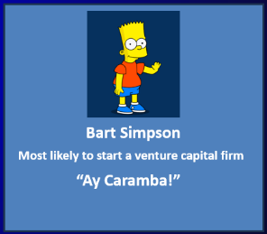
- Picture
- Name
- A quote
- A “most likely to…”

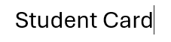

If you don’t recognize an image, ask your friend who it is! Bonus mark if you know Scooby Doo’s full name! Also, bonus mark if your quotes/most likely etc, make me laugh!
These students should be organized on the page, using only what he have learned as of the end of week 10, in the following manner:
- On a large screen, show the student card sizes that make sense.
- Cards should wrap so that there are only full student cards shown
- On a screen less than 500px wide, change the card background color
- The yearbook page should be as aesthetically pleasing and responsive as possible. It should look good now matter what device I’m viewing it on!
Feel free to add any imgs, cool things that you want to make the page fun and interesting (think img:hover etc) but, remember, only use stuff that we have learned so far.
Feel free to include other students if you wish! Have fun with it.
As always, upload your code to the server, zip up your code and submit it to dropbox as well as a link in the comments that will allow me to load the page from your server.

